**Supplemental Materials for Kindertransport Unit**

*\*To access full versions of the material, click the associated image.\**

[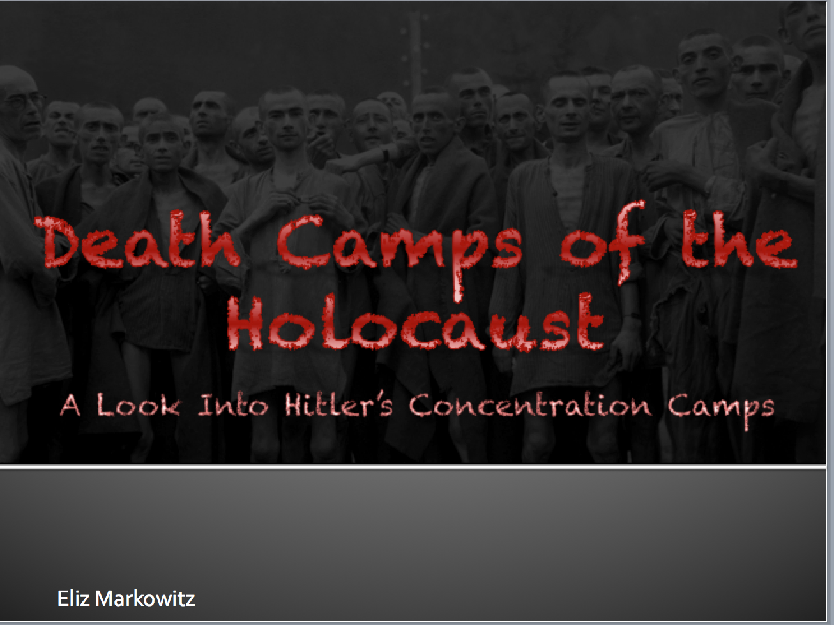](https://drive.google.com/file/d/0B-A9sEbRMMSoMldSWXo2ZTI5LVE/edit?usp=sharing)[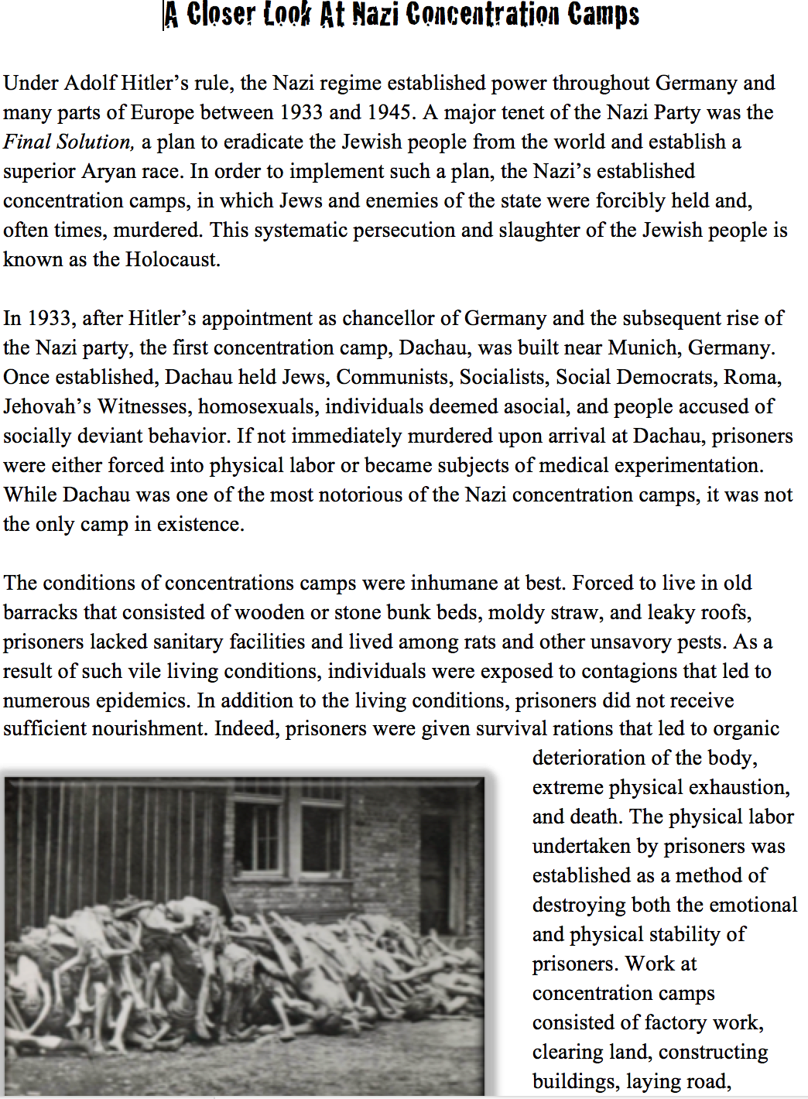](https://drive.google.com/file/d/0B-A9sEbRMMSoRnlnZl92WkdvcmM/edit?usp=sharing)[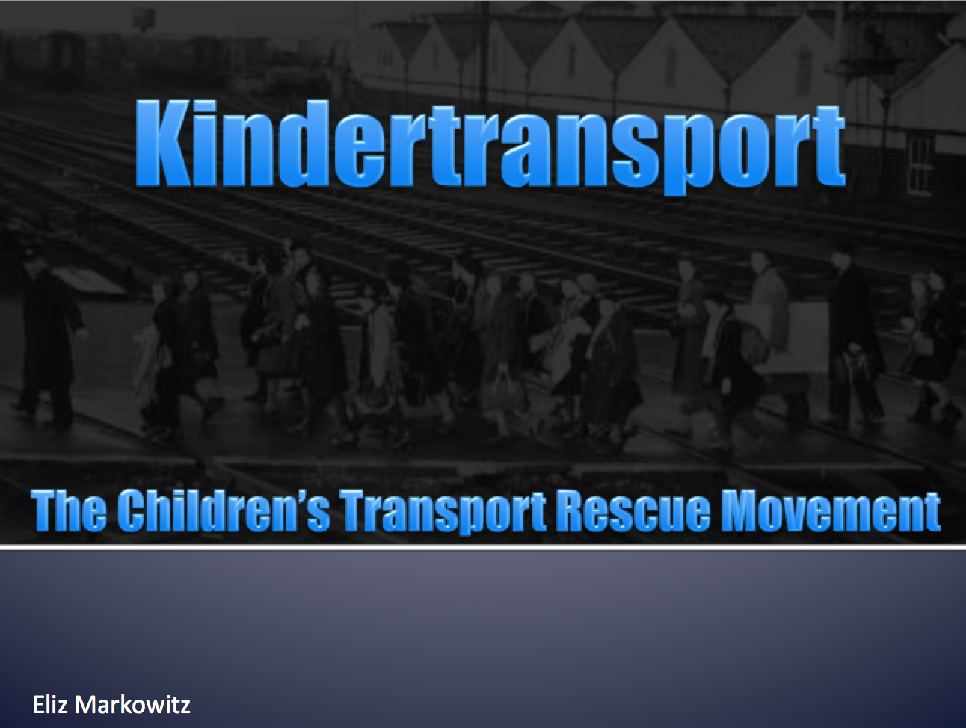](https://drive.google.com/file/d/0B-A9sEbRMMSoLXVLY3R3NzhXWms/edit?usp=sharing)

This presentation explores the concentration camps implemented by Hitler during the Holocaust. In addition to exploring the types of concentration camps, information regarding camp conditions and daily life is explored. Please note that many of the images in this presentation are graphic in nature.

This document provides a brief summary of the establishment and conditions of Nazi concentration camps. In addition to the summary, this document also contains a written assignment. For the assignment, students are asked to research a concentration camp survivor and compose an essay that recounts the personal experiences of that survivor.

This presentation explores the conception and implementation of the Kindertransport. In addition, this presentation addresses the events that took place before, during, and after Kristallnacht, which, arguably, led to the creation of the Kindertransport.