A Closer Look At Nazi Concentration Camps

Under Adolf Hitler’s rule, the Nazi regime established power throughout Germany and many parts of Europe between 1933 and 1945. A major tenet of the Nazi Party was the Final Solution, a plan to eradicate the Jewish people from the world and establish a superior Aryan race. In order to implement such a plan, the Nazi’s established concentration camps, in which Jews and enemies of the state were forcibly held and, often times, murdered. This systematic persecution and slaughter of the Jewish people is known as the Holocaust.

In 1933, after Hitler’s appointment as chancellor of Germany and the subsequent rise of the Nazi party, the first concentration camp, Dachau, was built near Munich, Germany. Once established, Dachau held Jews, Communists, Socialists, Social Democrats, Roma, Jehovah’s Witnesses, homosexuals, individuals deemed asocial, and people accused of socially deviant behavior. If not immediately murdered upon arrival at Dachau, prisoners were either forced into physical labor or became subjects of medical experimentation. While Dachau was one of the most notorious of the Nazi concentration camps, it was not the only camp in existence.

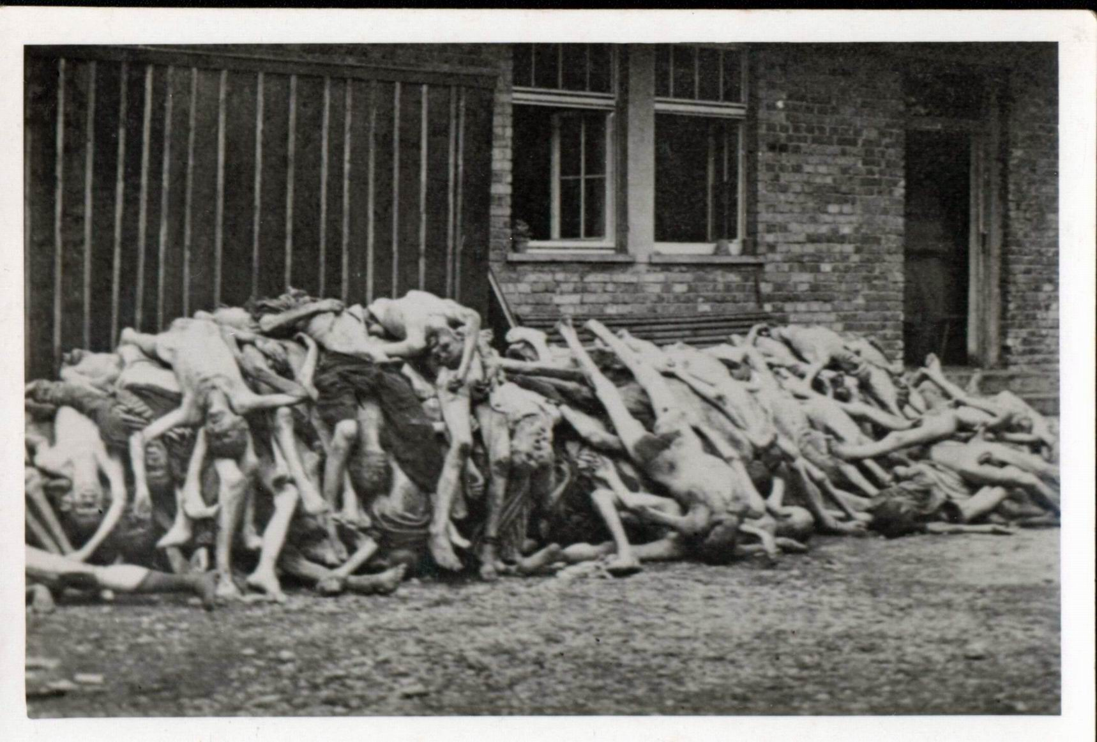
The conditions of concentrations camps were inhumane at best. Forced to live in old barracks that consisted of wooden or stone bunk beds, moldy straw, and leaky roofs, prisoners lacked sanitary facilities and lived among rats and other unsavory pests. As a result of such vile living conditions, individuals were exposed to contagions that led to numerous epidemics. In addition to the living conditions, prisoners did not receive sufficient nourishment. Indeed, prisoners were given survival rations that led to organic deterioration of the body, extreme physical exhaustion, and death. The physical labor undertaken by prisoners was established as a method of destroying both the emotional and physical stability of prisoners. Work at concentration camps consisted of factory work, clearing land, constructing buildings, laying road, mining, and digging both ditches and mass burial sites. If soldiers were unsatisfied with a prisoner’s work ability, the prisoner would be beaten or killed. However, prisoners were not solely punished for work ethic. The Nazis viewed execution as a means of eliminating weak individuals, creating space for incoming prisoners, or furthering the goal of eradicating the world of Jewish people.
After being murdered in the Dachau gas chamber, prisoners were callously thrown into piles and buried in mass graves.
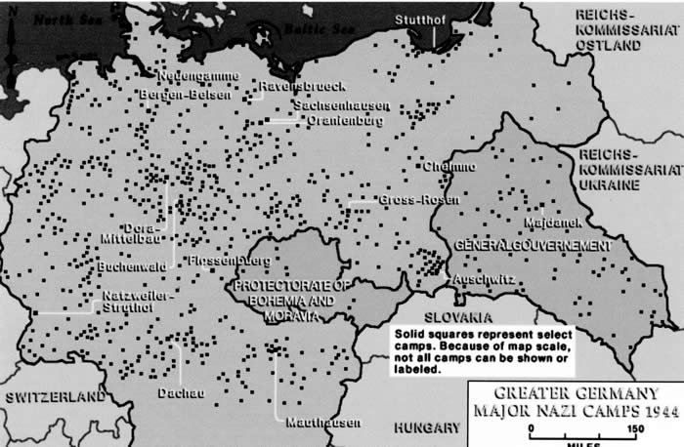
A map of some of the 20,000 concentration camps in Europe during 1933-1945
During Hitler’s reign, approximately 20,000 concentration camps were established throughout Germany, Holland, Austria, Poland, Ukraine, Slovakia, Czechoslovakia, and Estonia in an effort to implement the Nazi’s Final Solution. Over the course of the Holocaust, an estimated 11 million people were murdered, of which six million were Jews. Upon conclusion of World War II, it was determined that the Nazi’s were responsible for the genocide of nearly two-thirds of all the Jews that lived in Europe. While there are no exact figures regarding the number of concentration camp survivors, historians estimate that at least 200,000 individuals survived imprisonment.

Writing Assignment

While historians have documented the known facts of the Holocaust and the concentration camps in which millions of innocent victims were murdered, such history fails to capture the memories and personal histories of individuals subjected to such treatment. For this assignment, you are to research a concentration camp survivor and compose an essay in which you discuss the personal experiences of a concentration camp victim. In your essay, consider addressing the following:

Why was the survivor sent to a concentration camp?
How did the survivor arrive at the camp? What were the transportation conditions?
What was the processing procedure?
What memories does the survivor have of life in a concentration camp?
How did the survivor manage to live through such a horrific experience?
What long-term effects did imprisonment have on the victim’s life?

